Sign In App
Crib Sheet

Sign in App is the replacement for our current contractor system.
- Why do we need a replacement? – The current contractor system was designed as a temporary replacement during Covid, this system is not supported by IT, so this negates the change. Sign In App allows contractors to sign in an out which enhances our contractor management and site security.
- How do I get access - You have been sent a link to the system which you need to use to request initial access by using your University User name and password through the Single Sign in Process (SSO) one into the system there is a box that states request access, this will be processed by the System Admins and you will be notified once this is completed.
- How do I add Contractors to the system?
In the top left corner of the home screen, you will find the following options.
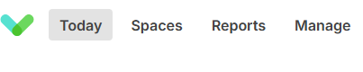
Click Manage
Click Groups
Click Contractors

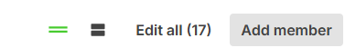
Click Add Member if this is a new contractor to the system or edit if you wish to amend a current contractor.
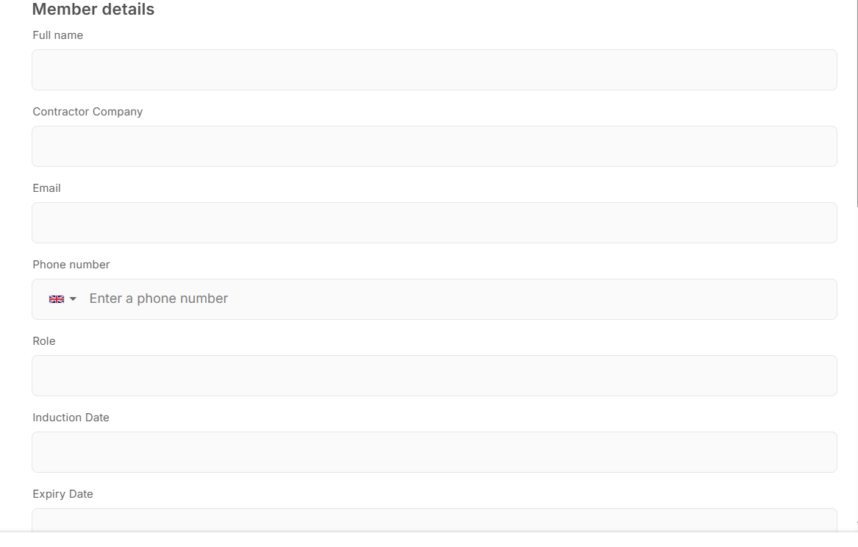This will open this page.
You will be asked to Fill in the following.
- Contractor name
- Company
- email address
- phone number
- Role – i.e. contractor, Surveyor etc
- Valid Induction date (This will be Monitored with incorrect dates those contractors will be removed from the system requiring the project manager to go through the process again)
- Expiry date on the system that they will be editable max 12 months.
- LU Project Manager
- Start and End Date of works (This should be for the duration of the works only)
You will then need to click the box to get the welcome email and QR code sent to the contractor.
Finally click save in the bottom left corner of the page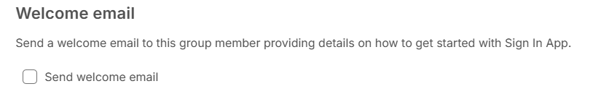

- What happens on the day for the contractor? - The contractor will attend one of the IPAD stations on launch this will be located just inside the help desk where they will present there QR code to the screen which will pick up his details. The system will ask if a photo is required to which the contractor will select yes, a photo will be taken, and a pass will be printed. Plastic wallets are available. They will at that point be signed in and will be required to sign out at the end of the day. Once they have their pass, they just sign in and out at the start and end of each day.
The sign in units is located at –

- FM yard helpdesk lobby (Installed)
- Charnwood Reception (Date to be confirmed)
- Security (TBC for out of hours works)
- Bridgeman (TBC)

- What do I do if there is an issue – All issues need to be directed to the FM Helpdesk as this is an estate managed system they will have day to day controlled who will work to resolve the issue for you?

